Hiking project 2 ideas

Mfullford/project 2



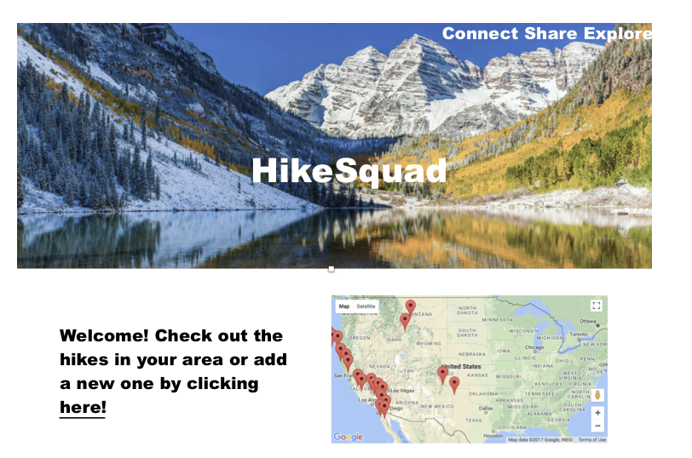

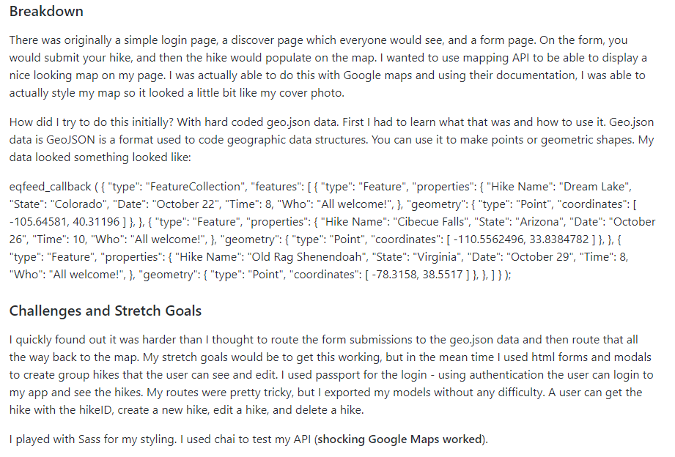

What it needed to work. It mentioned geojson?



BlerinaAliaj/HB-Project Hikr

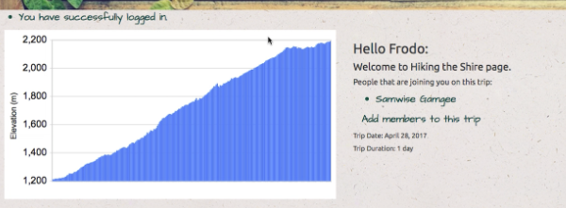

Like the elevation aspect of hike

Map with different color for different trails in area.

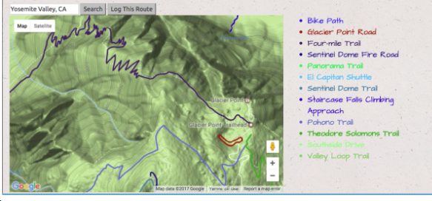

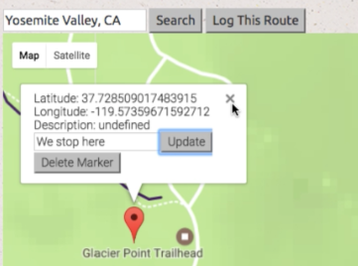

Latitude and longitude nice

[Esri](https://github.com/Esri)/[**hiking-trails-app**](https://github.com/Esri/hiking-trails-app)

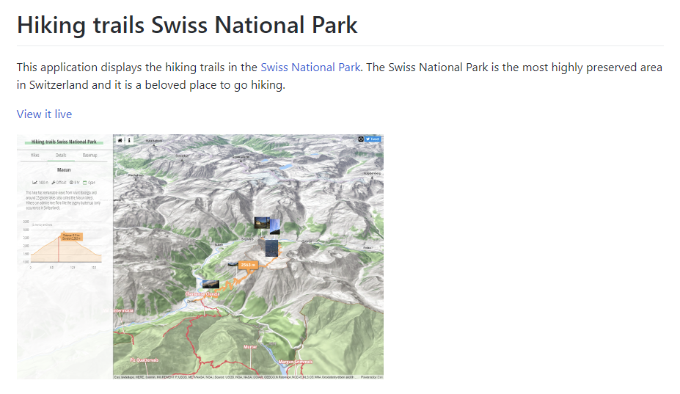

These guys just picked one park and mapped it. Should we just do Arizona to limit hiking feature and do it well?

## [hiking-trail-visualization](https://github.com/wuzhou-zhang/hiking-trail-visualization)/**trails_index.json**

This is based in sanfranciso only

Important need to have it as phone app so people can carry information with them on hike.

compassView?